Polling Bridge High Level Design

Description
This is a high level design document for a pull technology for messages and events originating on our applications outside the Talos network, and bringing the data into Analyst-Console which is inside the Talos network.

Purpose
Data, events, form submissions, et cetera, may originate on our applications outside our network. In particular the apps hosted on Heroku, Talos Intelligence, Snort.org, ClamAV, and Immunet. We need to send such data to an application inside the Talos network. An example of such data would be a false positive submission, which we would like to automate to creating a bug in Analyst-Console.
Data and events originating in Analyst-Console could easily be sent to an outside app through a web service. However, incoming web service connections are restricted by the Talos network firewall. Therefore, polling may be needed for communication in that direction.
There is need for bi-directional (or duplex) communication between inside and outside apps, and the Polling Bridge is a solution to that problem, sending messages out via web services, and polling via web services to bring data in.

Scope
This design, the Polling Bridge itself, is only concerned with the means of communication, and not the protocol of the messages.
Reliability might be omitted from the communication, in favor of having reliability features in the messages themselves. That is, the messages might send acknowledgement and confirmation, rather than the bridge tracking that messages have been acknowledged, and being responsible for a resending strategy. This is not necessarily the design, as later details may specify such reliability in the communication itself, but it is mentioned here to illustrate the distinction between the communication and the messages.
Messages might be for false positive submissions, but the design of the communication in the Polling Bridge design does not regard what traffic will be communicated.
This design also does not limit the gamut of applications which can participate in the scheme. However, analyst-console is central to the design, as it is the only internal app initially being considered, with all other apps being external. Also, Talos Intelligence is an anchor for the external applications, and may be the other point the communication is tethered to.

Components
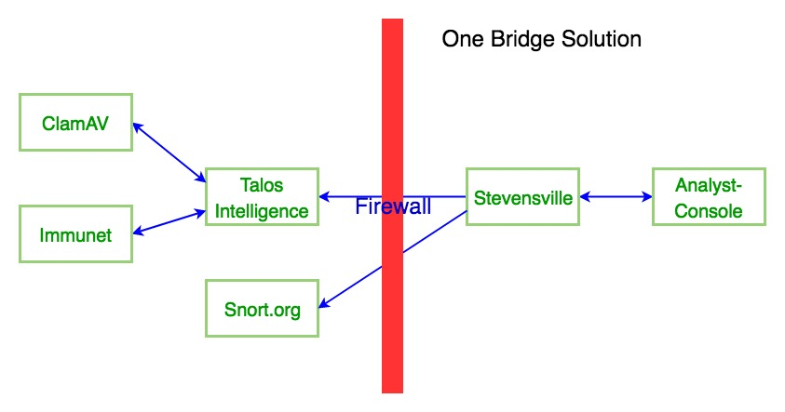

Analyst Console
Analyst Console is a Rails app for our security analysts hosted internally in the Talos network. It plays a central role in the Polling Bridge as it is the motivation for communication with our customer facing apps externally hosted on Heroku with it. (This rails app may be the harness application which hosts the poller for a zero bridge solution, not considered here.)

Stevensville Bridge
The peake-bridge application will be deployed on the host `stevensville`, essentially the internal bridge. The bridge will do whatever is needed to talk with `analyst-console`, bi-directionally (duplex), even given the requirement that analyst-console requires Kerberos authentication. The peake-bridge app will also be enhanced to poll an app on herkoku. It will also directly call web services. Thus it can act as a clearing house for the messages.

Peake-Bridge-Client
The peake-bridge-client is a ruby gem which wraps Net::HTTP calls to send a message. The benefit of using this gem wherever possible to make web service calls is that it enforces a standard message format and a standard web service call. It may also have a few addition features which are commonly useful in our environment, such as Kerberos authentication.
This client gem would be used by analyst-console, the stevensville bridge, Talos-Intelligence, and pictured here, Snort.org.

Heroku Apps
Our Heroku apps are Talos Intelligence, Snort.org, ClamAV, and Immunet. They will originate events and messages, and consume notification of events and messages.

Talos-Intelligence
Unless requirements expanding drives us to isolate the external communication into its own app, Talos-Intelligence will be the communication hub and queue for unsent message.
The benefit of limiting the communication to one application is the greater security of communicating through an application which has a very narrow gamut of who it will accept communication with. The alternative of communicating directly with the Heroku apps would co-exist with a customer facing user interface and could not be as effectively restricted.
Talos-Intelligence would store a queue of undelivered messages waiting for the poller to call and read the messages. When an event or message originates on our customer facing Heroku apps, the Heroku app would call a web service on the Talos-Intelligence to add the message to the queue. Since our core communication in our current plans is Talos-Intelligence, hopefully, other communication will be limited.

Snort.org
If other Heroku apps need to exchange messages with analyst-console, they can communicate with Talos-Intelligence to queue them. An exception to this will be Snort.org, where users may file false positive reports. The reason for the exception is that the false positive forms in Snort.org are planned for obsolesces.

Message Format
The message format of the body of the HTTP request is a JSON representation of a hash with and envelope key and a message key. The envelope key has a hash value with standard strict values which should be with any message. The message key has a hash value with a flexible format, which is only specific for a given message type.

Message Controller Standard
Different apps receiving messages may have a different URI base, but there is a specific RESTful format for the URI.
The message is sent as the “application/json” MIME type. Rails should parse the JSON into the params with the envelope data in params[‘envelope’], and the message in params[‘message’].

Queuing
Undelivered message are stored in the Talos-Intelligence Heroku app. It will store the queue of undelivered messages in its own database.

Station Message Records
There should be a field in the database record with the whole JSON representation of the message, including both the envelope and the message body. Other fields might include the parts of the envelope.

Scheduling
The polling that the hub does might be written as rake tasks, called by a job scheduled with the UNIX cron utility.
Other scheduling may be implemented for web services to schedule a job to be processed later, so they can return right way.

